

School of Informatics & IT

AY 2022/2023 Oct Semester (Level 2)
Diploma In Cybersecurity & Digital Forensics
Incident Response and Management (ICRM)
[Subject Code – CDF3C01]

ASSIGNMENT REPORT

FOR

INCIDENT RESPONSE AND MANAGEMENT

Declaration of Non-plagiarism

Submitted by:
2100461i Mohamad Zikry Bin Fawzi
2100902B Isaac Tan
2100346B Low Chi Shun Caeden
2100467F Muhammad Nur Haiqal Bin Abdul Kader
2100342A Lee Chee Hsien

Date: 29/12/2022

“By submitting this work, I am / we are declaring that I am / we are the originator(s) of this work and that all other original sources used in this work has been appropriately acknowledged.

I / We understand that plagiarism is the act of taking and using the whole or any part of another person’s work and presenting it as my/ our own without proper acknowledgement.

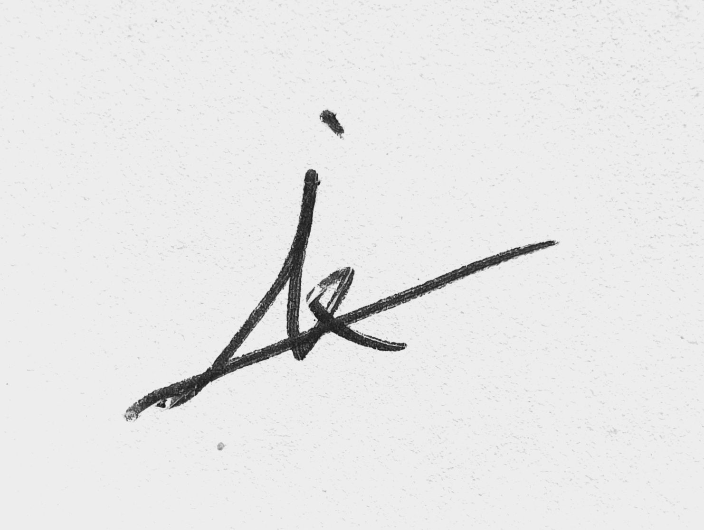
I / We also understand that plagiarism is an academic offence, and that disciplinary action will be taken for plagiarism.”


Name and Signature of student: ……………………………………

Name and Signature of student: ……………………………………

Name and Signature of student: ……………………………………

Name and Signature of student: ……………………………………

Name and Signature of student: ……………………………………

Gathering Basic Information

